FMS DEVELOPMENT ENVIRONMENT

UI Developer Guidance

***Version 1.0***

***Dec 6, 2021***

Table of Contents

I. Introduction 3

FMS (Fraud Manager System) project is a part of Shinhan Finance ecosystem. It supports internal tasks for D&R team. 3

II. Install Required Software 3

1. Node.js and npm 3

2. Angular CLI 3

3. GIT & Source code 3

4. Java Development Kit (JDK) 4

❖ Install 4

❖ Verify 4

5. Tomcat server 4

III. Configurations 4

IV. Build 5

V. NOTE 6

1. Introduction

FMS (Fraud Manager System) project is a part of Shinhan Finance ecosystem. It supports internal tasks for Fraud team.

1. Install Required Software
2. Node.js and npm

* If Node.js and npm aren't already on your machine, install them. <https://nodejs.org/en/download/>
* To check which version you are using, run ***node -v*** and ***npm -v***, please make sure that you don’t use node version older than 15.x.x and npm version older than 7.x.x

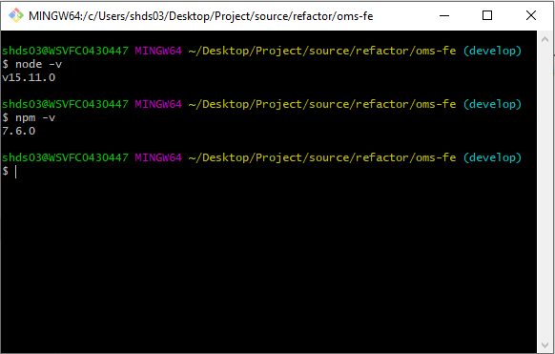

1. Angular CLI

* Install the CLI using the node package manager:

***npm install -g @angular/cli***

1. GIT & Source code

* Install GIT follow the link:
  + <https://git-scm.com/download/win>
* Get latest code on branch **release**
  + <https://git.shinhanfinance.com.vn/internal/fms-system>

1. Java Development Kit (JDK)

* Install
* Download a copy of the Java SE 8 Development Kit. Be sure to select the proper version to match your operating system.
* <http://www.oracle.com/technetwork/java/javase/downloads/index.html>
* Right click on the file and select ***Run as administrator***.
* During the installation, accept all the default values by pressing the ***Next*** button on all screens.
* If applicable, ignore the product registration screen/page after the installation is complete.
* Make a note of the folder where Java is installed.
* Verify
* Open a DOS window.
* Enter the following command: ***java –version***
* You should see a message like the following (your version number or build number may vary):

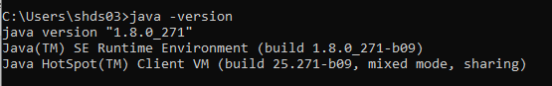

* Enter the following command: ***javac –version***
* You should see a message like the following (your version number may vary):



* Verify that both messages show a Java version that starts with 1.8. If you do not see these messages, go back through the installation steps for the Java JDK.

1. Tomcat server

* Install Tomcat server follow the link:
* <https://tomcat.apache.org/download-90.cgi>

1. Configurations

* In ***fms-system/FE/src/environments*** folder, open ***environment.prod.ts*** file and config the backend url

**NOTE:**

* Base_url – connect to FMS Server

1. Build

* In workspace directory ***fms-system/FE***
* Run ***npm install*** to download all dependency packages
* Run ***ng build --prod --aot --output-hashing=all --base-href=”/fms/”*** to compile source code into an output directory named ***dist/***

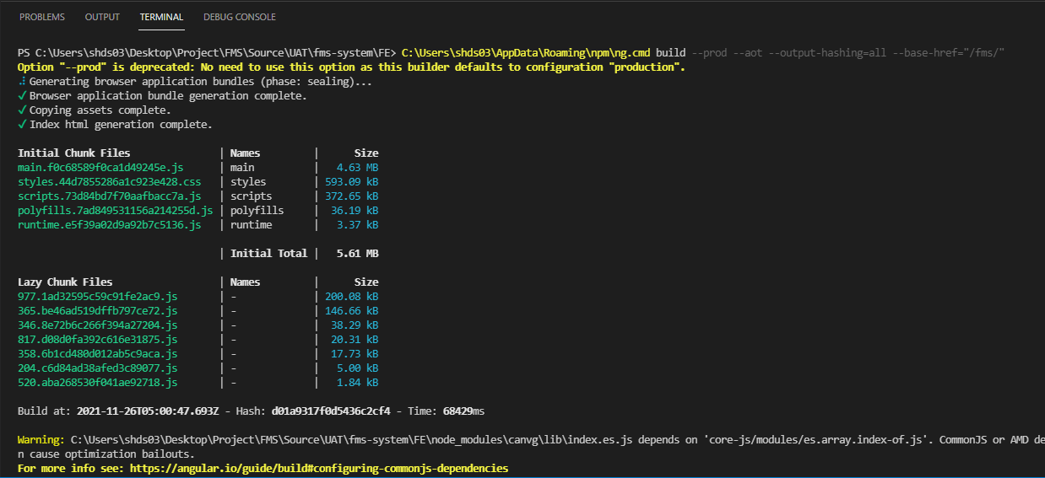

**NOTE:**  Make sure the ***base-href*** is “/fms/” ( 2 slash at start & end)

* In ***dist/FMS/*** folder, open cmd window. Run ***jar cvf fms.war .***

* Put ***fms.war*** file into Tomcat Server

* Start Tomcat server then check the Web app

1. NOTE

In-case the server starts unsuccessfully. Please check and configuration these steps:

1. Configure the **RewriteValve** in server.xml

* Edit the ***~/conf/server.xml*** to add the below Valve inside the Host section as below

<Valve className="org.apache.catalina.valves.rewrite.RewriteValve" />

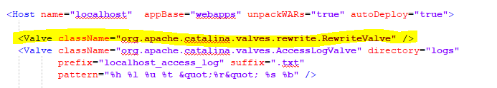

1. Write the rewrite rule in rewrite.config

* Create directory structure ***~/conf/Catalina/localhost/*** and create the ***rewrite.config*** file inside it with the below

RewriteCond %{REQUEST_PATH} !-f  
RewriteRule ^/fms/(.*) /fms/index.html [L]

1. Restart Tomcat server after configurating